

SIMATS ENGINEERING
Saveetha Institute of Medical and Technical Sciences Chennai- 602105
Student Name: T. Subahan Reg. No.: 192511121
Course Code: CSA0718 Slot: B
Course Name: Artificial Intelligence
Course Faculty: Dr. R. Jeena

Project Title: AI-Enabled Smart Agriculture System Using IoT Sensors
Module Photographs: (3 photographs –Module Photo, Individual student contribution module work in the project and presentation image)
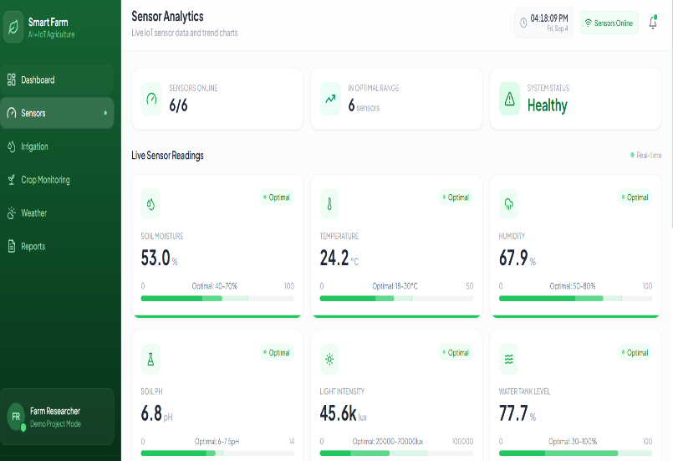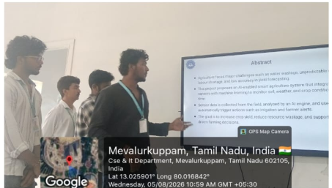
Project Description: (here you write what you did in this project (contribution) including Model Description
The Sensing Layer is the first and most important layer of the AI-Enabled Smart Agriculture System Using IoT Sensors. Its main purpose is to collect real-time information about agricultural field conditions using various IoT sensors. Sensors such as soil moisture, temperature, humidity, pH, and light intensity sensors are deployed in the field to continuously monitor environmental and soil parameters.
The collected sensor data is transmitted to a microcontroller or IoT gateway, where it can be processed and forwarded to the higher layers of the system. The sensing layer helps identify important conditions such as insufficient soil moisture, excessive temperature, low humidity, and unsuitable soil conditions. This real-time data provides the necessary input for the AI-based decision-making system.
The module reduces the need for manual monitoring and enables farmers to obtain accurate information about crop and soil conditions. The data collected by this layer is later used by the AI and decision-making modules to provide recommendations for irrigation, crop management, and other agricultural activities.

Student Signature Guide Signature

